|  |  |  |  |  |  |  |  |  |  |  |  |  |  |  |  |  |  |
| --- | --- | --- | --- | --- | --- | --- | --- | --- | --- | --- | --- | --- | --- | --- | --- | --- | --- |
| Logo Berilmu Berbakti low | | | | | | | | | | | | | | | | | |
| **FACULTY OF ENGINEERING** | | | | | | | | | | | | | | | | | |
| **Test 1** | | | | | | | | | | | | | | | | | |
| **First Semester of 2021/2022** | | | | | | | | | | | | | | | | | |
|  | **COURSE NAME** | | | | **:** | | **COMPUTER PROGRAMMING** | | | | | | | | | | |
|  | **CODE** | | | | **:** | | **ENG 3202 / ECC 3005** | | | | | | | | | | |
|  |  | | | |  | |  | | | | | | | | | | |
|  | **PROGRAMME** | | | | **:** | **BACHELOR OF COMPUTER AND COMMUNICATION SYSTEMS ENGINEERING WITH HONOURS** | | | | | | | | | |  |
|  | **LECTURER** | | | | **:** | **DR. SITI BARIRAH AHMAD ANAS / MDM ROSLIZAH ALI** | | | | | | | | | |  |
|  | **DATE** | | | | **:** | **30 NOVEMBER 2021** | | | | | **VENUE** | | | **:** | **ONLINE** |  |
|  | **TIME** | | | | **:** | **9.00 – 10.00 PM** | | | | | **DURATION** | | | **:** | **1 HOUR** |  |
|  | **Instructions** | | | | **:** |  | | | | | | | | | | | |
|  | 1. | Answer **ALL** questions. Answers have to be typed /written in the question paper.  *(Jawab* ***SEMUA*** *soalan. Jawapan hendaklah ditaip/ ditulis di dalam kertas soalan.)* | | | | | | | | | | | | | |  |
|  | 2. | Upload your answers to PutraBLAST within the time allocated.  *(Muat naik jawapan anda ke PutraBLAST dalam masa yang diperuntukkan).* | | | | | | | | | | | | | |  |
|  | **Name** | | **:** | **ALIFF NABIL IZZUDIN BIN BADRUL HISHAM** | | | | | | | | | | | | | |
|  | **Matric No.** | | **:** | **210277** | | | | **Programme** | | | | **:** | **CCSE** | | | | |
|  | **Seat No.** | | **:** | - | | | | **Signature** | | | | **:** | **ALIFF** | | | | |
|  |  | |  |  | | | |  | | | |  |  | | | | |
|  | This paper consists of | | | | | | | **8** | pages including the front page | | | | | | |  |
|  |  | | | | | | |  | |  | | | | | |  |

@ UPM All rights reserved

1. Indicate whether the following statements are True (T) or False (F) (10 marks)

(a) **Myname** and **myName** are two different variables in C++. ( T )

(b) Pseudocode is a collection of instructions that ( F )

the computer can understand.

(c) Before execution, all C++ programs must be (F )

translated by an interpreter.

(d) Examples of high-level languages are Lisp, Ada, R and Ruby. ( T )

(e) The arithmetic logic unit performs arithmetic operations ( T )

and detects the logical errors of a program.

(f) Text editor is a systems software. ( T )

(g) A program written in Python language ( T )

is called a source program.

(h) Logical errors occur at run-time. ( T )

(i) The purpose of a header file, such as **<iostream>**,  ( F)

is to store a program’s source code.

(j) The operating system is the hardware that manages  ( T )

the overall operation of a computer system.

2. State the final value of variable **num** in each of the following expressions. Show the complete workings to obtain your answer.

(NOTE : answer without workings will not be given any marks.) (5 marks)

1. **num = ( 3 * 9 * ( 3 + ( 9 * 3) / 3 * 3 ) );**

**num = ( 27( 3 + ( 27) / 9 ) );**

**num = ( 27( 3 + 3) );**

**num = 243**

ii) **num = ( 2945 % 100 ) / 10 % 10 ;**

**num = ( 2945 % 100 ) / 0 ;**

**num=0**

1. **num = 10 + 5 > 5 && 2 < 1;**

**num = true && false;**

**num = false;**

**num = 0;**

1. **num = 100 > 3 && ‘a’ > ‘d’;**

**num= true && false;**

**num=false;**

**num=0;**

1. **num = (10 +14) / 2 * 3 || 6 - 2 % 7;**

**num = (24/6) || (6-2);**

**num = true;**

**num=1;**

3. Given the program below, answer the following questions:



(i) Trace the program by filling in the values for **j**, **num1** and **num2** in Table 1 for each loop iteration. (3 marks)

Table 1

|  |  |  |  |
| --- | --- | --- | --- |
| Iteration number | j | num 1 | num2 |
| 1 | 10 | 10 | 10 |
| 2 | 7 | 12 | 10 |
| 3 | 4 | 12 | 14 |
| 4 | 1 | 14 | 14 |
| 5 | -2 | 14 | 18 |

(ii) What is the output of the program? (1 mark)

Num1 is 14 and num2 is 18

(iii) Convert the **for** loop (from the line commented with A until the line commented with B) into a **while** loop. (3 marks)

int main(){

    int num1=10;

    int num2=10;

    int j=10;

    while (j>=-2)

    {

        if(j%2 !=0)

            num1 = num1+2;

        else

            if(j%5!=0)

                num2=num2+4;

        j-=3;

    }

    cout << num1 << num2 << endl;

}

4. i) Convert the following algorithm into an equivalent flowchart to solve the

problem. Draw the flowchart on the next page. (5 marks)

**Flow chart**

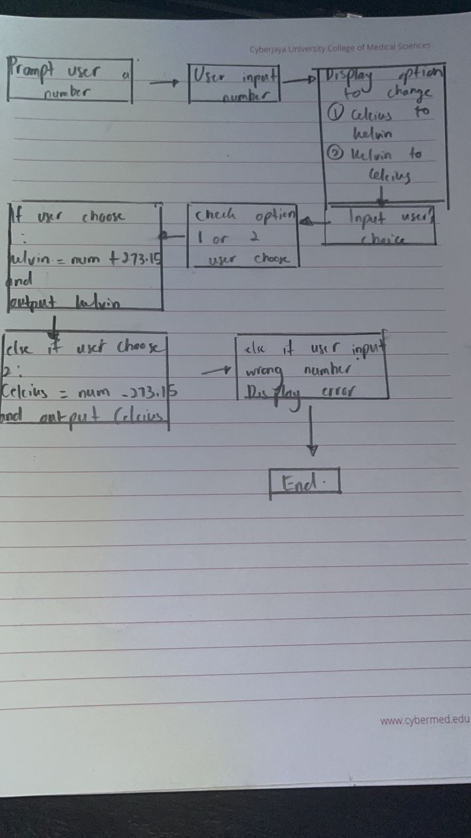

ii) Explain TWO (2) differences between an algorithm and a flowchart.

(2 marks)

Flowchart is a step-by-step representation of how a block of code is running which can be understood by humans while algorithms are a block of code which the computer understands and executes accordingly.

Flowchart is easier to detect and debug any errors since it is just a representation which shows the flow of a block of code while algorithm are more harder to detect and debug error since it is an implantation of the flowchart in programming language.

iii) Write a complete C++ program to implement the flowchart using a **switch** statement. (NOTE : Submit the **.cpp** file for this section.) (7 marks)



#include <iostream>

using namespace std;

int main(){

    int a,b,c;

    float output;

    cout << "enter an integer number : " << endl;

    cin >> a;

    cout << "What option do you want ? \t Press 1 : Celcius to Kelvin \t Press 2 : Kelvin to Celsius" << endl;

    cin >> b;

    if (b==1)

    {

        output = a + 273.15;

        cout << "Kelvin is :" << output << endl;

    }

    else if(b==2)

    {

        output = a - 273.15;

        cout << "Celcius is :" << output << endl;

    }

    else

    {

        cout << "----INVALID OPTION-----" << endl;

    }

*return* 0;

}

iv) Rewrite the **switch** statement in Question 4(iii) using nested **if-else** statements. (4 marks)

(NOTE : you DO NOT have to write the whole program again)

**ASCII table**

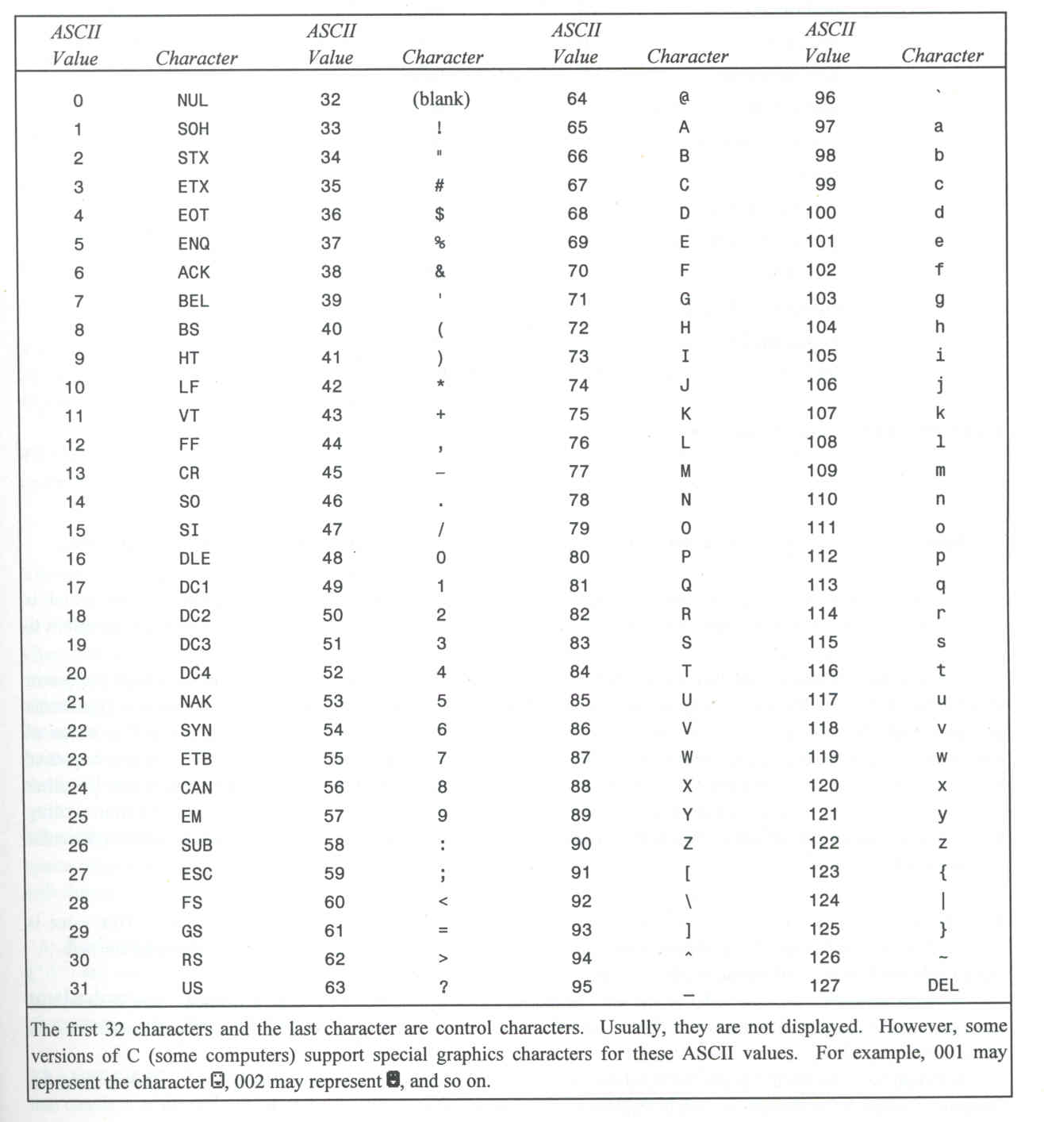

**Operator Precedence and Associativity**

